NESNE TABANLI PROGRAMLAMA ÇALIŞMA SORULARI

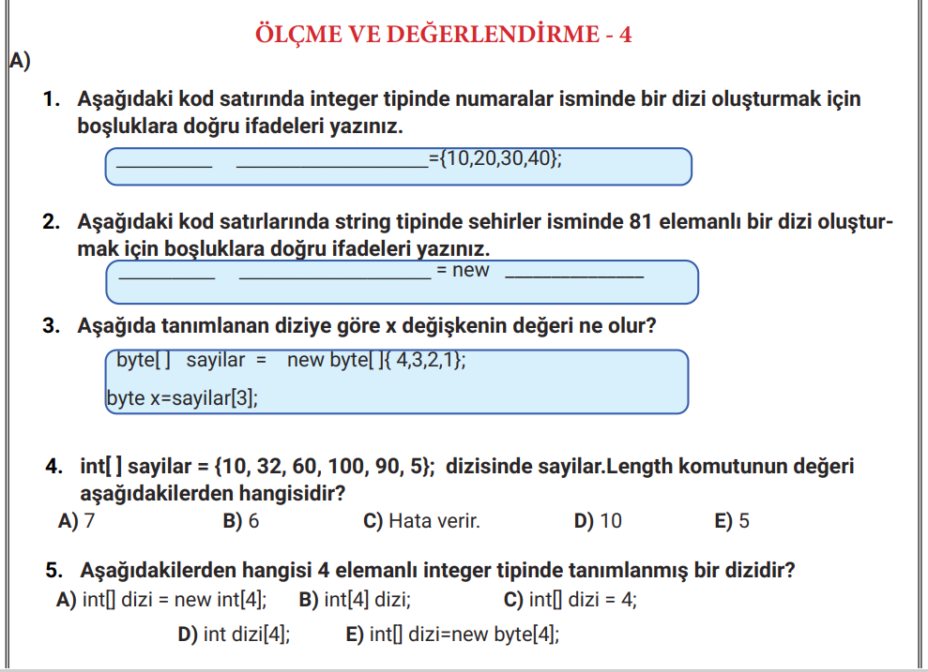
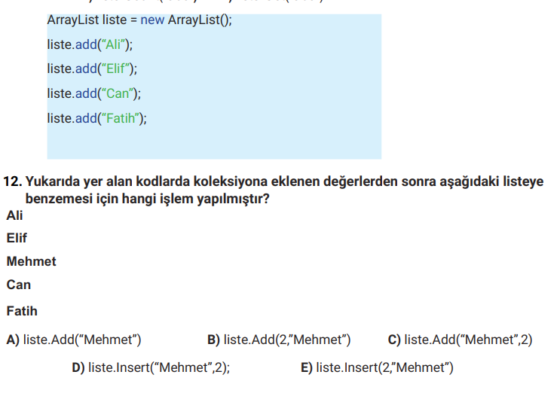

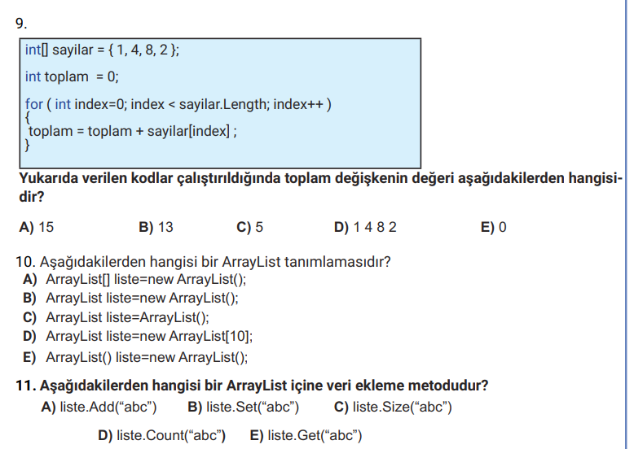
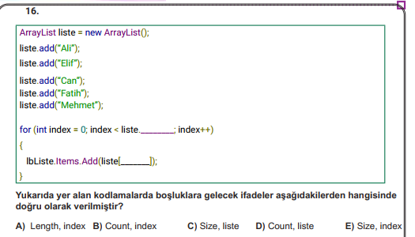
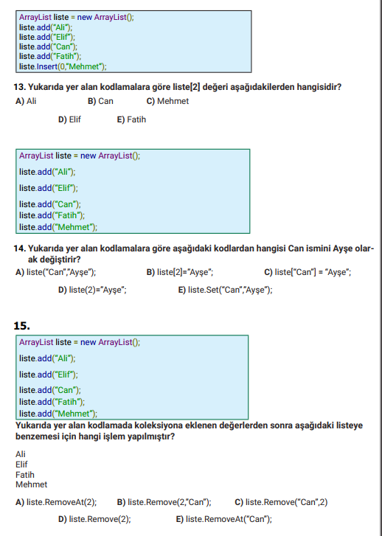

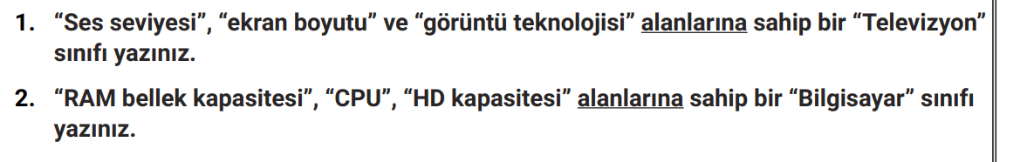

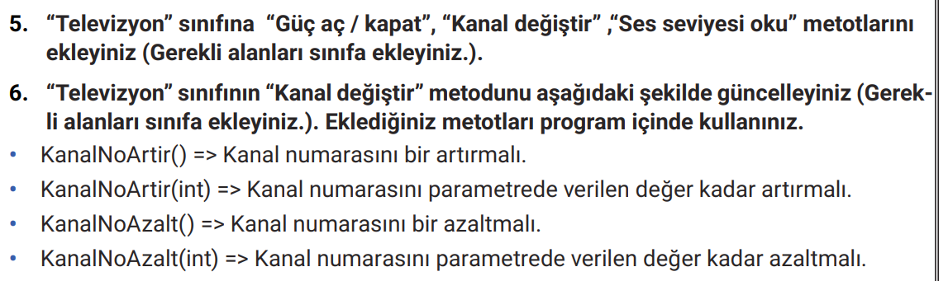

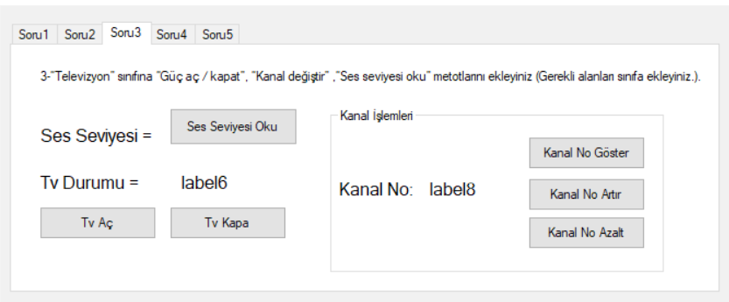

TELEVİZYON SINIFI
using System;
using System.Collections.Generic;
using System.Linq;
using System.Text;
using System.Threading.Tasks;

namespace ORNEKSORULAR
{
class Televizyon
{
public int sesSeviyesi=5;
int ekranBoyutu;
string goruntuTeknolojisi;
bool gucAcik = false;
int kanalNo = 1;

public string GucAc(){
gucAcik = true;
return " Televizyon Açıldı";
}
public string GucKapat()
{
gucAcik = false;
return " Televizyon Kapalı";
}
public string SesSeviyesiOku()
{
return sesSeviyesi.ToString();
}

public int KanalNoArtir(){
return this.kanalNo++;
}
public int KanalNoAzalt()
{
return this.kanalNo--;
}
public string KanalNoGoster() {
return this.kanalNo.ToString();
}

}
}

FORM KODLARI
using System;
using System.Collections.Generic;
using System.ComponentModel;
using System.Data;
using System.Drawing;
using System.Linq;
using System.Text;
using System.Threading.Tasks;
using System.Windows.Forms;

namespace ORNEKSORULAR
{
public partial class Form1 : Form
{
public Form1()
{
InitializeComponent();
}
Televizyon tv = new Televizyon();

private void button1_Click(object sender, EventArgs e)
{
label4.Text+= tv.SesSeviyesiOku();
}

private void button2_Click(object sender, EventArgs e)
{
label6.Text= tv.GucAc();
}

private void button3_Click(object sender, EventArgs e)
{
label6.Text = tv.GucKapat();
}

private void button6_Click(object sender, EventArgs e)
{
label8.Text = tv.KanalNoGoster();
}

private void button4_Click(object sender, EventArgs e)
{
label8.Text = tv.KanalNoArtir().ToString();
}

private void button5_Click(object sender, EventArgs e)
{
label8.Text = tv.KanalNoAzalt().ToString();
}
} }

